Specification for Web site

Name: Ayyub Azmat

Student Number: 19334103

Programme: Commerce International (Year 1)

Module: MIS10040 Web Design and Analytics

Lecturer: Darren Redmond

**Specification for Web site**

Proposed domain name: [www.powersoundarklow.ie](http://www.powersoundarklow.ie)

**Overview of Website Requirement**

My new site will perform the following functions for the business:

* Allow people to browse the products and services sold by the business.
* The site will also enable visitors to make purchases on-line.
* The website will also allow visitors to sign up for a newsletter as a once of sign-up

Other requirements:

* The website should be accessible to search engine spiders and be coded with good on-page search engine optimisation.
* The navigation system should be intuitive and easy to follow. It should allow the visitor to quickly navigate the site starting from any page.
* Optimise the website to improve its search engine optimisation rankings.

**Primary Content of Web site**

**1 Home Page**

The home page will give visitors an overview of our services.

**2 Products Category 1**

This page will give an overview of each of our products from this category

**3 Product Category 2**

This page will give an overview of each of the products in this category

**4 Online Shop**

Each product page will have a link that will allow visitors to place an order on-line.

**5 Contact Us**

Full contact details including a map.

**6 Site Map**

A site map should be provided showing the structure of the site and linking to every page on the site.

A common navigation bar should be included on all pages. The navigation bar will include links to the home page, products list, about us, and contact details.

**Secondary content of web site**

**Testimonies:** Short articles describing how our services have benefited clients.

**About us:** A page with details about our company, perhaps including a short history. This page might include or link to a page showing pictures of your employees and a short summary of their expertise.

**Sign up:** A sign up page for a newsletter

**Functionality and usability**

* The site will feature drop down menus on every page. A search box will appear on the home page and will give the visitor the option of an advanced search.
* A concise and clutter free interface will be provided

**Style and layout**

* Each page on the site should feature our company logo.
* The site should include our corporate colours.
* The website should try incorporating images as buttons
* The layout should be uniform throughout the website
* A common navigation bar should be included on all pages. The navigation bar will include links to the home page, products list, about us, and contact details.

**Additional requirements**

**Accessibility**

* The site must comply with W3C WAI (World Wide Web Consortium Web Accessibility Initiative) level A Guidelines.
* The site will contain alt text which will enhance the accessibility for visually impaired users.

**Code validation**

* All code on the site should validate to W3C (World Wide Web Consortium) specifications.

**Maintenance**

* It must be possible for us to update the content of the site using a low-cost software package.
* The web designer will provide on-site training to one of the staff to use this software package.

**Hosting**

* A reliable web host will be found for the completed site, and the designer will load the site onto the web and set up E-mail, FTP access, and carry out any other administration necessary to set up the site.

**Support**

* Any bugs or errors found on the site after launch will be rectified free of charge.

Wireframes



Initial design for loading page, the logo will be a button leading to the homepage. Writing should be incorporated to tell visitors and customers to click on the logo to proceed to main website.



Possible design for the interface and layout of the pages.

Logo Design

I decided to create a logo for the client as they didn’t have one. I took inspiration for the logo from the products they sell, (musical instruments and fishing gear).

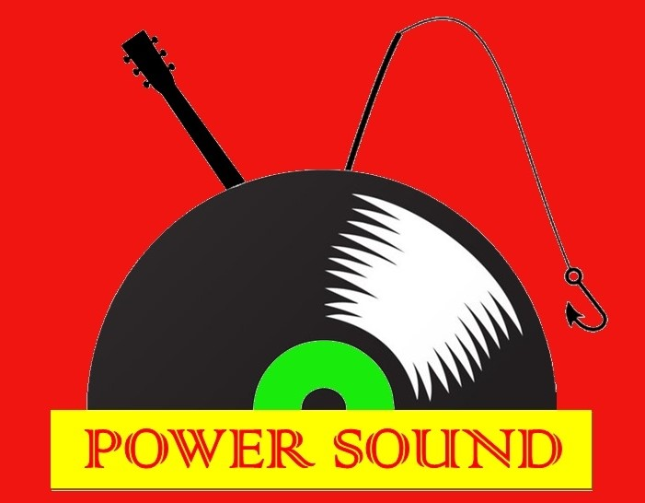

Sitemap

* Home
* Musical instruments
  + Wind
  + Brass
  + String
  + Percussion
  + Keyboards
  + Traditional Irish instruments
* Fishing
* About us
  + Testimonies
  + Sign up for newsletter
* Contact us
  + Phone number/email
  + Map
  + Social media